**Joye Purser, PhD**

**Representative from the Office of the Secretary of Defense**

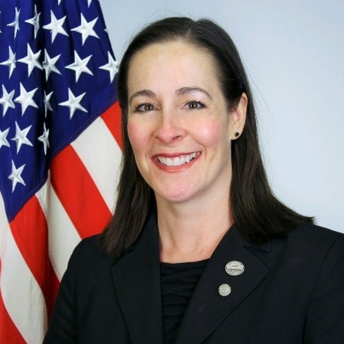Dr. Purser serves as Deputy Director for Analysis and Innovation for the Director of Cost Assessment and Program Evaluation (CAPE) within the Office of the Secretary of Defense. In this role, she leads in the development of quality analytical products for the Joint Staff. She previously was on-detail as the Defense Science and Technology Examiner within the National Security Division at the Office of Management and Budget in the White House. There, she managed all science-related budget proposals from the Department of Defense; and she advised on how new or developing legislation, policies, world events, or industry activities may affect the technological superiority of the American warfighter. She devoted a particular focus on interagency issues related to trusted microelectronics.  
  
Prior to her White House detail, Dr. Purser served within CAPE as a senior program analyst and adviser to the Secretary of Defense: leading and directing evaluations of science, space, health IT, and C4 programs, as well as chemical/ biological defense, counter-terrorism, and homeland defense programs. She came to the Pentagon in 2011 as the special assistant to the Director of CAPE. Before that, she worked for multiple Members of Congress as a seven-year Capitol Hill staffer for health, science, and energy policy. Additionally, she has worked for a nonprofit advocacy organization, Research America, that teaches scientists and engineers how to effectively advocate and message to Congress and other decision makers. She founded and owns a consultancy as a scientific writer.

Dr. Purser earned a PhD in molecular microbiology from the University of Texas and completed undergraduate studies at Georgia Tech. Her life’s mission is to do good for scientists. She lives in the Washington, DC, area with her husband and two children.